

**Environmental Footprint Calculator**

**For Poultry Producers**

User’s Manual  
Apr, 2016  
  
  
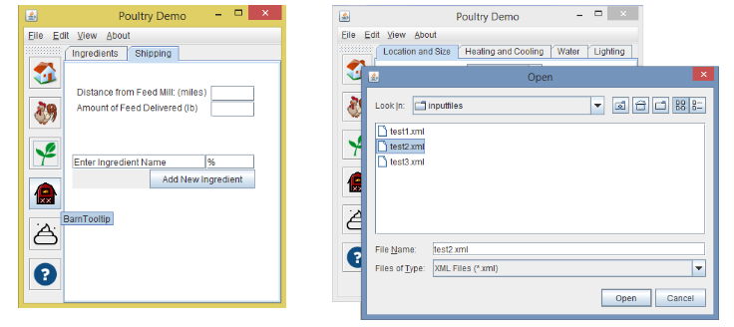

**Tables of contents**

Contents

1. Introduction 3

2. Capabilities of the Calculator 4

3. Quick Start 5

3.1 How to Install the Program 5

3.2 How to Launch the Program 5

3.3 How to Run a Saved Farm Case 5

4. Features and Screens 6

4.1 Home Panel 6

4.2 Bird Panel 6

4.3 Feed Panel 6

4.4 Barn Panel 6

4.5 Feed Panel 6

4.6 Test Input 6

4.7 Result 6

5. Interpreting the Output 7

6. Comparing Cases 8

7. Saving and Printing a File to pdf 9

7.1 Save or Print to pdf Farm Level Output 9

7.2 Save or Print to pdf Barn Level Output 9

7.3 Save or Print to pdf Results from a Two Case Comparison . 9

8. Help and Technical Support 10

# 1. Introduction

The software should take in various inputs such as poultry breed, ambient temperature and feed composition, as well as specifics for the facility such as number of houses and type of manure management system(s). Through various UI elements we will supply the user with comprehensive data about the model of their facility, and give detailed information about the carbon, water and land footprints these facilities produce.

The look and feel of the software will be that of a native Microsoft Windows application. It will have internal windows which are re-sizable and manipulable, specifically allowing the user to copy/paste to and from the software. It will provide saving and loading of farm data and output as well.

Chicken farmers must make decisions on their farms that require the use of energy sources, food intake, and production skills throughout their day to produce poultry at a justifiable cost. Generally, chicken farmers must maintain multiple commodities to manage their chickens. These include heating, light sources, food, air circulation, to name a few. Optimizing all of these commodities will help the farmers to reduce the cost of operation while maximizing the production of their poultry. The calculator created through this implementation should allow for poultry industry workers to analyze possible optimizations they can make to producing poultry with a usable user interface. This should allow for poultry farmers and the like to create better goals for themselves regarding their practices.

# 2. Capabilities of the Calculator

# 3. Quick Start

## 3.1 How to Install the Program

## 3.2 How to Launch the Program

## 3.3 How to Run a Saved Farm Case

# 4. Features and Screens

## 4.1 Home Panel

## 4.2 Bird Panel

## 4.3 Feed Panel

## 4.4 Barn Panel

## 4.5 Feed Panel

## 4.6 Test Input

## 4.7 Result

# 5. Interpreting the Output

# 6. Comparing Cases

# 7. Saving and Printing a File to pdf

## 7.1 Save or Print to pdf Farm Level Output

## 7.2 Save or Print to pdf Barn Level Output

## 7.3 Save or Print to pdf Results from a Two Case Comparison .

# 8. Help and Technical Support